


www.clansoftsolutions.com

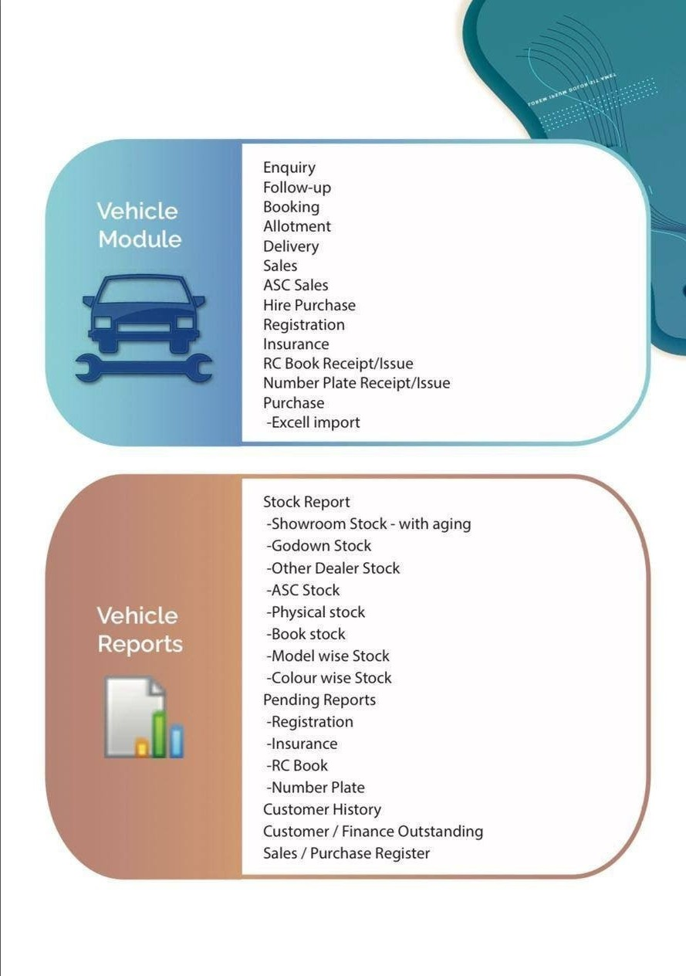

www.clansoftsolutions.com

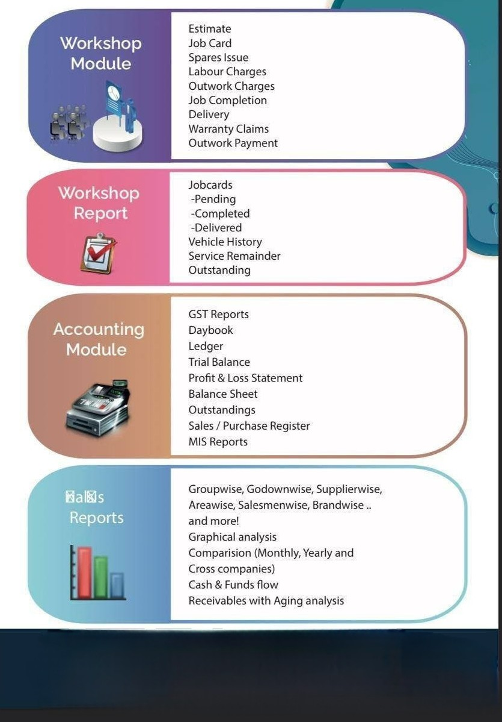


9894956500 / 9787773317
www.clansoftsolutions.com

